Project Design Phase
Solution Architecture
Date | 02 NOVEMBER 2025
Team ID | NM2025TMID01366
Project Name | Laptop Request Catalog Item
Maximum Mark | 4 Marks

Solution Architecture
Goals of the Architecture:
- Provide a digital, automated process for laptop requests through the service catalog
- Ensure dynamic and accurate data entry using UI Policies and Catalog Client Scripts
- Improve service efficiency by reducing manual approval time • Enable transparency through request tracking and status updates
Key Components:
- Service Catalog Item (Laptop Request) – main entry point for users to request laptops
- Catalog UI Policies – control visibility, mandatory fields, and field behavior dynamically
- UI Actions – provide custom buttons like “Reset Form” or “Submit Request”
- Workflow / Flow Designer – manages the approval and fulfillment process • ServiceNow Tables – store request details, approval status, and history logs
Development Phases:
- Create a new Service Catalog Item for “Laptop Request.”
- Configure catalog variables (Laptop Type, Department, Justification, etc.).
- Implement UI Policies to dynamically hide/show fields based on conditions.
- Add UI Actions (like Reset Button) to enhance form functionality.
- Design approval workflow for manager validation and IT fulfillment.
- Test form behavior and verify request tracking across all user roles.

Solution Architecture Description:
The solution architecture for the Laptop Request Catalog Item focuses on creating a seamless and automated process for employees to request laptops through the ServiceNow platform. The architecture integrates UI Policies, Client Scripts, and Workflows to ensure a dynamic and user-friendly experience.
When an employee fills out the catalog form, UI Policies automatically adjust visible fields based on selections (e.g., laptop type or role). UI Actions allow quick actions like resetting or submitting the form. The request is then routed through a pre-defined approval flow before fulfillment by IT support.
This architecture ensures improved accuracy, faster approvals, and better transparency. It eliminates repetitive manual steps, allowing administrators to track requests easily and maintain accurate hardware allocation records.
Example – Solution Architecture Diagram:

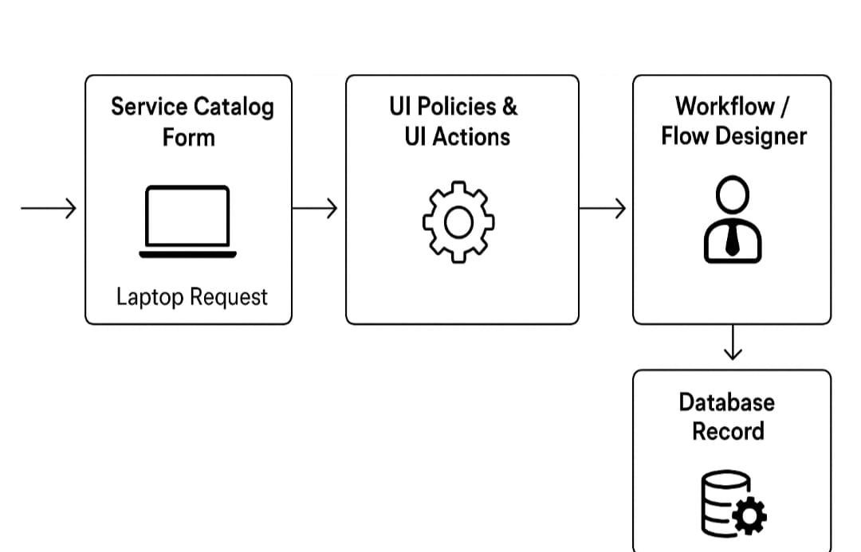

Figure 1: Architecture and data flow of the Laptop Request Catalog Item application

Reference:
https://developer.servicenow.com/dev.do#!/learn/learning-
plans/paris/servicenow_application_developer/app_store_learnv2_csd_paris_catalog_item_de sign

